**PF Lab 5 assignment**

## **More Problems:**

# **Question 1**

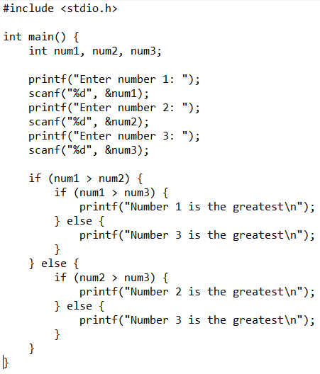

# Output

## **Question 2**

## **Output**

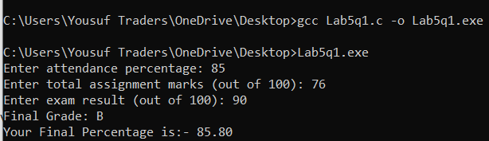

## **Question 3**

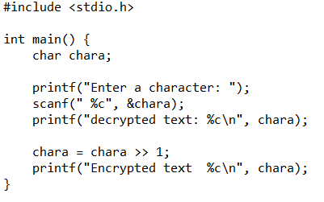

## **Output**

## **Question 4**

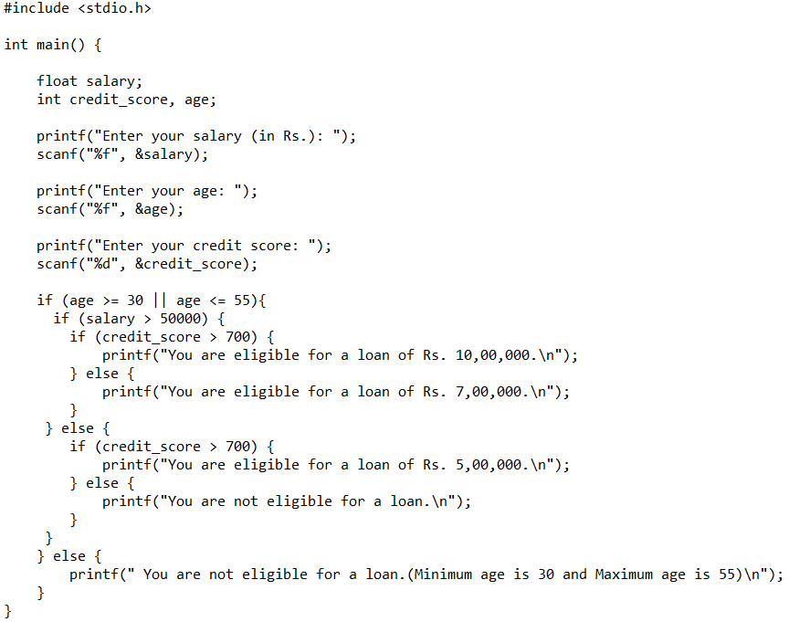

## Output

# **Section 1**

### **Question 1 Output**

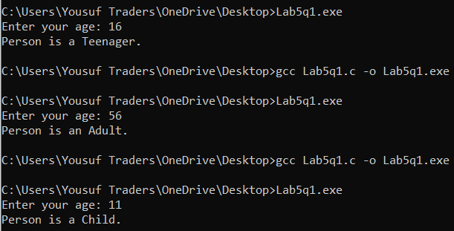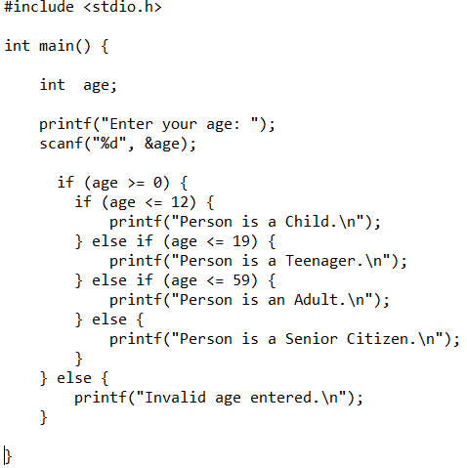

### **Question 2 Output**

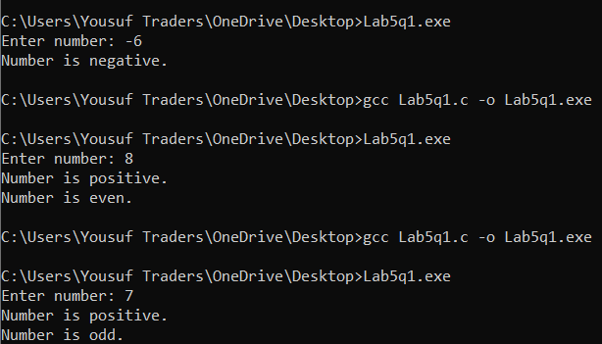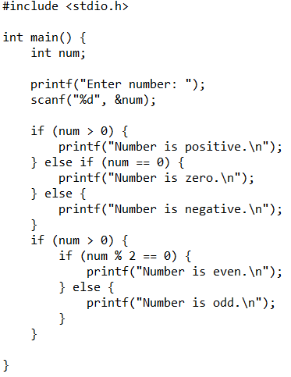

# **Section 2**

### **Question 1 Output**

**

## **Question 2**

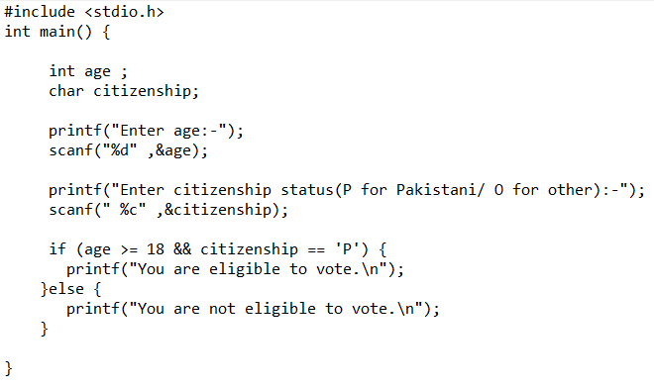**Output**

# Section 3

### **Question 1 Output**

**

## Question 2

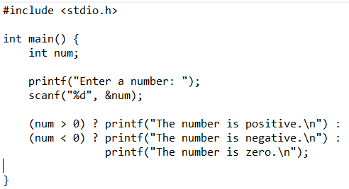

## **Output**

# **Section 4**

**Question 1 **Output**

# **Section 5**

## **Question 1**

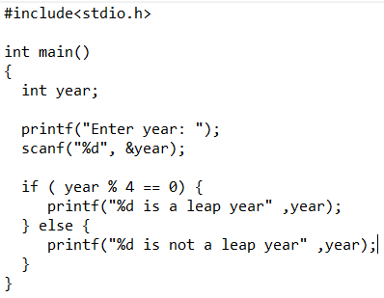

## Output

